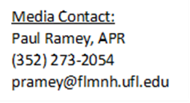
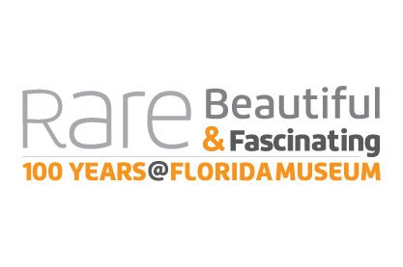
Rare, Beautiful & Fascinating: 100 Years @FloridaMuseum
Sept. 23, 2017-Jan. 7, 2018
Major Themes and Components

Objects Tell Stories
Learn about the key role museum collections play in telling the story of life of Earth. Objects in the collections hold secrets to past cultures and climates, including changes over time, and help track genetic change and diversity. Collection data is also being used to help solve many world issues, including climate change, water and air quality, and more.

History
While the exhibit celebrates the museum’s designation as the state natural history museum in 1917, the institution traces its roots to Florida Agricultural College in Lake City, where the first teaching collections were started in 1891.

Faces of the Museum
Through personal interviews, learn how the museum has affected the lives of many individuals, including employees, visitors, students, volunteers and other stakeholders. A story kiosk allows visitors to contribute their own memories or thoughts of the museum.

Working Lab
This working lab features a different museum collection area each week. Guests may gain a first-hand look at what goes on behind the scenes while observing and speaking with museum staff and students.

On the Brink and Extinct
These areas provide a glimpse of species that have gone extinct over the past 100 years, including actual specimens from the museum collections. Learn why scientists believe we are currently in the midst of Earth’s sixth mass extinction event and hear about some of the museum’s conservation efforts to save threatened species on the brink of extinction, including Schaus’ swallowtail butterflies.

Technology
Technology has improved how researchers utilize the collections. For example, CT scans allow an object to be studied without damaging it, and at the same time provide a way for the data to be shared with researchers, students and the public worldwide. Visitors can learn about some of these initiatives and view a 3-D printer in action as it replicates collection objects.

Mobile experience
Visitors may access a link from their own mobile device that includes an exhibit audio tour allowing them to hear scientists discussing interesting stories about the objects (Bring your earbuds!). Guests may also participate in a scavenger hunt, using riddles as clues to find museum objects. Tablet devices will also be available for check out.

