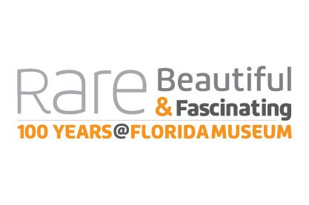
Rare, Beautiful & Fascinating: 100 Years @FloridaMuseum
Sept. 23, 2017-Jan. 7, 2018
Did You Know?
- Lionfish have long, venomous fin spines and are an invasive species in North and South America. “Rodeos” help control their spread and educate anglers on safely collecting them.
- The invasive Cuban tree frog is the largest tree frog species in Florida—up to 5 inches long.
- The air potato is a plant native to tropical Asia that thrives in Florida due to the warm climate – it can grow 8 inches a day.
- A sea cucumber can throw out its gut when disturbed and regenerate it.
- The luna moth evolved long tails that it spins as an acoustic deflector against predatory bats.
- Humpback whales don’t eat in the winter when breeding--they live off their fat preserves.
- The northern mockingbird can imitate the songs of at least 50 other species of southern birds. It can even mimic car horns and car alarms.
- Titanoboa is the world’s largest snake. Scientists estimate it could have been 45 to 50 feet long and 3 feet wide, weighing over a ton.
- Agatized coral forms over time when the coral’s original calcium carbonate skeleton is slowly dissolved by acidic groundwater and partially replaced by dissolved silica, which creates beautiful specimens with cave-like appearances.
- The oldest-known grapes were growing in Central India before humans existed.
- In the Caribbean, native people frequently used alcohol or hallucinogens during ceremonies to communicate with spirits.
- Highly skilled potters sculpted animals onto effigy vessels, giving a glimpse of creatures that held symbolic importance.
- Christopher Columbus established the short-lived settlement La Navidad in what is now Haiti. Artifacts from the site, such as musket balls, suggest violent interactions between the Spaniards and the local Taíno.
- The Nazca people of Peru often painted figures such as the fox deity, known in Peruvian religion as the animal counterpart of the moon, on their pottery.
- Clam shells form yearly growth rings that record changes in the marine environment.
- Early Seminoles made traditional baskets from split saw palmetto stems but introduced sweetgrass baskets in the early 20th century to sell for extra income.
- The Lakota traditionally used dyed porcupine quills to adorn items such as tobacco pouches.

