**Rose Red-Filmed by Any Other Name: A Genealogy of Pottery Typology in the Southeastern US**

**Lindsay Bloch and Amy Alleman**

Lindsay Bloch is collections manager of the Ceramic Technology Lab at the Florida Museum of Natural History, University of Florida. Amy Alleman is a volunteer in the Ceramic Technology Lab at the Florida Museum of Natural History, University of Florida

Working with legacy collections, it’s common to come across labeled artifacts or reports listing now defunct names. Rather than treating them as a nuisance to be updated, what can we learn from these names as historical artifacts themselves? For us, this issue arose when we began rehabilitating a study collection of pottery from the Southeastern United States. The sherds had been given to researchers at the Florida Museum in the 1950s and 1960s, from institutions such as Moundville Historic Site, the Peabody Institute, UT-Austin, and Louisiana State University (LSU). For the most part, sherds were labeled with type names in pen and ink.

For this project, the purpose was to ascertain the currently accepted type names, image the sherds for a digital type collection, and rehouse to modern standards. What ensued was a rabbit hole down to the early history of archaeology in the Southeastern US. It was evident from the labeling and age of their boxes that these assemblages had not been updated since their arrival at UF. In one case, they had never been removed from the shipping box (Figure 1). While these sherds were safely tucked away in their cabinet in the museum basement, decades of discovery and debate had changed their names and their significance. Each collection formed a time capsule, evidence of a typological moment in Southeastern archaeology. Here, we focus on a subset of this collection, 404 sherds from the Lower Mississippi Valley (LMV) that were sent to UF in 1956, from LSU.

Archaeologists have a fraught relationship with typology. We create types as organizational tools in the present day, a lingua franca to translate the unique qualities of every archaeological assemblage or site to say something meaningful at a broader scale. At the same time, we recognize our inability to know how much or if these categories had cultural significance in the past (Ford and Steward 1954; Krieger 1944; Phillips and Willey 1953; Wylie 2002). Types are by definition shorthand, categories that downplay certain kinds of variation in favor of other attributes that are given primacy. This sets up inherent weaknesses since most attributes are not simply present or absent, but exist on a spectrum. As synthetic products, pottery vessels bear the marks of human action and individual manufacture at every turn. It’s difficult to create and maintain bounded categories in the face of nonstandard objects. With any typological scheme, we must reconcile our goals of objectivity with the subjective reality of the archaeological artifacts.

**Background**

In the 1930s, driven mainly by the rapid influx of archaeological materials from WPA excavations, and other large Depression-era projects, archaeologists working in the Southeast became increasingly concerned with creating a system for describing and sharing regionally applicable ceramic types (Figure 2). In particular, researchers had the goal of developing a regional chronology, which would rely heavily on ceramic change over time. Typing was essential for developing these seriations. Prior to this, vessels had been described individually, or sherds were identified in general terms, with few efforts at systematic quantification.

The archaeologists in the Southeast drew upon typological systems already implemented in places like the American Southwest. Recognizing the need to establish consensus among many different projects and personalities at work, in 1938, 15 men (yes, all men) convened the Conference on Southeastern Pottery Typology at the Ceramic Repository for the Eastern US, in Ann Arbor, Michigan (Ford and Griffin 1937, 1938). The result was the development of a model for typological description, defining naming conventions and criteria. Names were to consist of two or three parts: a geographical name, an optional descriptive modifier, and a dominant attribute, or constant related to surface treatment. For example: a full three-part name is Deptford Check Stamped; a more basic two-part name is Coles Creek Incised. On the heels of this, the newly formed Southeastern Archaeological Conference (SEAC) published type descriptions following the agreed-upon format in their newsletter (e.g., Haag 1939), and it was adopted in subsequent scholarly publications. This system of typological description quickly became standard in the Southeast, and is found in the typological references that continue to be important today, forming the bases of our regional typologies (e.g., Phillips et al. 1951; Suhm and Jelks 1962; Willey 1949).

However, naming in the Southeast was not to be a simple process. At the turn of the century, scholars had bemoaned the lack of research in the Southeastern US (Lyon 1996:23). Earlier phases of excavation by people like C. B. Moore were more antiquarian in nature and focused on recovering whole vessels. The Great Depression changed that. Many large-scale public works projects were developed throughout the region to employ out of work citizens. Though they moved quickly, these new excavations of the 30s and 40s were more scholarly and systematic, excavating stratigraphically and recovering many thousands of sherds and other artifacts. As results of excavations undertaken by different teams across the region were discussed and integrated, multiple provisional type names representing the same wares came head to head. Dispersed excavations and new eyes provided information that broadened the scope of a type geographically, shifted its chronological position, or challenged its “constant” attributes. In this dynamic atmosphere, types were in a state of flux, compared to one another, and debated by those in favor of lumping, and those invested in splitting.

James Ford was one of the men at the forefront of this process, and was responsible for many of the names developed for the particular sherds in our collection, through his work at LSU during the Depression. While appreciating that many of Ford’s names have stood the test of time, his splitting methods were not always conducive to widespread adoption. Philip Phillips (1970:47) wrote a bit about Ford’s method of sorting Marksville Plain: “[Ford] claims to be able to sort it by the sound it makes when dropped on the table, and I’ve seen him do it, but this is a special skill that cannot be transmitted through the printed page.” Marksville Plain was later subsumed as Baytown Plain, so Ford lost that particular type. Overall, he was deeply invested in the development and refinement of Southeastern types, culminating in his monograph seriating pottery for a large swath of the Southeastern US (Ford 1952).

In the 1938 methods paper arising from the typology conference, Ford and James Griffin provide eight examples of “names which are already in use and which promise to become standard.” Of these, one was obsolete within 10 years (Deasonville Red on White= now Nodena Red & White *var. Ellison*). Another was almost immediately subsumed, Vining Simple Stamped became Mossy Oak Simple Stamped. In a twist, 40 years later that decision was reversed, and the original name was reinstated. Two other names had minor edits (Deptford Linear Stamped = Deptford Linear Check Stamped, Marksville Zoned Stamped = Marksville Stamped). But if these were the names they were most confident about, where did that leave even more provisional types? This study collection offered an opportunity to trace the selection strategies for type names in Southeastern archaeology.

**Changing Names**

The sherds in this type collection had all been recovered from sites within Arkansas and Louisiana between 1933 and 1940, from large-scale projects, some of which have become type sites in Southeastern archaeology, such as Tchefuncte and Marksville. Others were similarly large projects, but were never reported on, such as Martin Baptiste Place (16AV25), excavated in 1940. 62 sherds also came from surface collection of multiple sites within the Lower Mississippi Survey (LMS), undertaken in 1940. These were projects overseen at least in part by researchers at LSU, and artifacts were analyzed, curated, and named at LSU where James Ford managed a laboratory.

In rehabbing this collection, along with deciphering provenience information, we went through the boxes and looked up each type name to determine if it was still in use, the first time it was referenced or described in print, and the last time it was referenced. If the name was not used anymore, we tried to figure out what had superseded it. The results were highly variable (Table 1). In the LMV collection, more than half of the names on the sherds were no longer correct. This was in part due to the widespread adoption of Philip Phillips’ type-variety system (Phillips 1958, 1970).

A majority of the 42 types listed had already been formally described by 1940, mostly in the SEAC newsletter between1939-1940 or in the report on Crooks Mound (Ford and Willey 1940). Eleven more were typed by the early 1950s, in the LMS report (Phillips et al. 1951), by George Quimby (Quimby 1951), or by James Ford (1952). Most of the remaining types never had published type descriptions, though they may have been imaged or at least mentioned in texts, such as Anna Brush Roughened and Peterhill Incised. The only two that we’ve found no reference to are Catahoula Quadrated Plain, which would now be identified as vessels with French Fork Incised rims, and Rose Red Filmed, now Old Town Red.

A majority of the types names have changed to some extent, often more than once. Four types had small name adjustments, such as Bayou L’eau Noire Incised shortened to L’eau Noire Incised. Ten changed from standalone ware types to varieties, following Phillips’ type-variety system. For example, Lulu Linear Punctated became Chevalier Stamped, *var. Lulu*. Nine types totally changed type name, which for the most part meant they were subsumed by a more successful type name: St. Francis Plain became Mississippi Plain. Jonesville Stamped became Manny Stamped, then Marksville Stamped, *var. Manny*. Of the original 42 types, modern naming conventions recognize at least 37 type-varieties.

A number of the type names were already obsolete when they arrived at the University of Florida in 1956, having been used as provisional types in the late 30s and early 40s, but never achieving widespread acceptance. 15 years doesn’t sound like a long time, but these were exceedingly productive years for Southeastern archaeology. The biggest mystery of this accession is why the donor, William Haag at LSU, would have sent these materials to his good colleague William Sears with obsolete names. Haag was a longtime editor of the SEAC newsletter, drafting and publishing type descriptions at the forefront of Southeastern typology. This is especially baffling for exceedingly obscure, apparently one-off names like Rose Red Filmed (Figure 3).

For the past year, we have been bending the ear of any Southeastern archaeologist who will listen about Rose Red Filmed. Who came up with it? When? To date, no one has heard of it, and the name has never, to anyone’s knowledge, appeared in print. The examples in our collection, recovered on the LMS, would now be identified as Old Town Red. The name does seem to follow the established convention of geographic name + modifier + constant. If Rose does refer to geography, it is likely relating to Rose Mound, a site that was part of the LMS. One of the “Rose Red” sherds in the type collection is from Rose Mound. Interestingly, the percentage of red-filmed ware is not actually very high at this site compared to other sites within the survey. However, it has long history of excavation and pot-hunting. Many unique vessels with zoned red filming were recovered within the mound by C. B. Moore and others in the early 20th c. So it could be that the name came from knowledge of those complete vessels rather than the surface finds recovered during the Lower Mississippi Survey.

Alternately, the name could be an example of someone going rogue (or *rouge)*, and attempting to establish a competing evocative name á la Old Town Red, which Griffin had made around the same time as a play on words for “painting the old town red.” (Phillips 1970:145). He was able to justify the name by the presence of the Old Town site in the LMS. The name Old Town Red was in use by the Survey at least as early as 1947, and was published in the LMS report in 1951. This leaves the name Rose Red Filmed well out of play by the mid 1950s, when these sherds showed up in Florida.

**Conclusion**

What this study collection teaches is that certain ware names have been more durable than others, but it’s unpredictable. The gradual changes to these type names in the system over the intervening 80 years are reflective of the complexity of pottery in the Lower Mississippi Valley, the range of artifact and site-based variation, and the tremendous amount of research that has taken place. Subsequent generations of archaeologists have filled in geographic or chronological links between ware types once thought distinct, and recognized patterned variation in types once glossed identically.

One must resist the impulse to assume a natural or inherent categorization of pottery or other artifact classes. In many ways our typological shifts are analogous to those taking place in the biological sciences. Increasingly biologists determine “relatedness” via DNA rather than appearance. For archaeology, visual attributes were historically critical to assess relatedness, but now microscopic or elemental variability is also often being used to group pottery in new ways.

For expediency, we use, and we teach types as fixed categories. But, recognizing that the names we use today are mutable is a critical way to emphasize that the discipline functions within a constant state of evolution, and all is subject to revision. We now recognize the hubris of labeling artifacts with permanent ink. At the same time, these old labels, boldy writ, maintain the material traces of key historical moments in our discipline, a record of revisions and legacies that deserve scholarship in their own right.

**References Cited**  
Ford, James A., and James B. Griffin  
 1937 [A proposal for] Conference on Pottery Nomenclature for the Southeastern United States. *Southeastern Archaeological Conference Newsletter* 7(1):5–9.

1938 Report on the Conference on Southeastern Pottery Typology. *Southeastern Archaeological Conference Newsletter* 7(1):10–22.

Ford, James A., and Julian H. Steward  
 1954 On the Concept of Types. *American Anthropologist* 56(1):42–57.

Ford, James A., and Gordon R. Willey  
 1940 *Crooks Site: A Marksville Period Burial Mound in La Salle Parish, Louisiana*. Louisiana Department of Conservation, Anthropological Study No. 3.

Ford, James Alfred  
 1952 Measurements of some prehistoric design developments in the Southeastern States. *Anthropological Papers of the AMNH* 44(3).

Haag, William G.  
 1939 [Description of pottery types]. *Southeastern Archaeological Conference Newsletter* 1(1).

Krieger, Alex D.  
 1944 The Typological Concept. *American Antiquity* 9(3):271–288. DOI:10.2307/275785.

Lyon, Edwin A.  
 1996 *A New Deal for Southeastern Archaeology*. University of Alabama Press, Alabama, UNITED STATES.

Phillips, Philip  
 1958 Application of the Wheat-Gifford-Wasley Taxonomy to Eastern Ceramics. *American Antiquity* 24(2):117–125. DOI:10.2307/277473.

1970 *Archaeological Survey of the Lower Yazoo Basin, Mississippi, 1949-1955*. Vol. 160. Papers of the Peabody Museum of Archaeology and Ethnology. Harvard University, Cambridge, MA.

Phillips, Philip, James A. Ford, and James B. Griffin  
 1951 *Archaeological Survey in the Lower Mississippi Alluvial Valley, 1940-1947*. Vol. 25. Papers of the Peabody Museum of American Archaeology and Ethnology. Peabody Museum, Harvard University, Cambridge, MA.

Phillips, Philip, and Gordon R. Willey  
 1953 Method and Theory in American Archeology: An Operational Basis for Culture-Historical Integration. *American Anthropologist* 55(5):615–633.

Quimby, George Irving  
 1951 The Medora site, West Baton Rouge Parish, Louisiana. *Field Museum of Natural History, Anthropological Series* 24(2):81–135.

Suhm, Dee Ann, and Edward B. Jelks  
 1962 *Handbook of Texas Archaeology: Type Descriptions*. Texas Archaeological Society, Special Publication no. 1, and Texas Memorial Museum, Bulletin no. 4. Austin, TX.

Willey, Gordon R.  
 1949 *Archeology of the Florida Gulf Coast*. Vol. 113. Smithsonian Miscellaneous Collections. Smithsonian Institution, Washington, D. C.

Wylie, Alison  
 2002 *Thinking from Things: Essays in the Philosophy of Archaeology*. University of California Press, Berkeley.

Table 1. Comparison of ca. 1940 type names to modern type names.

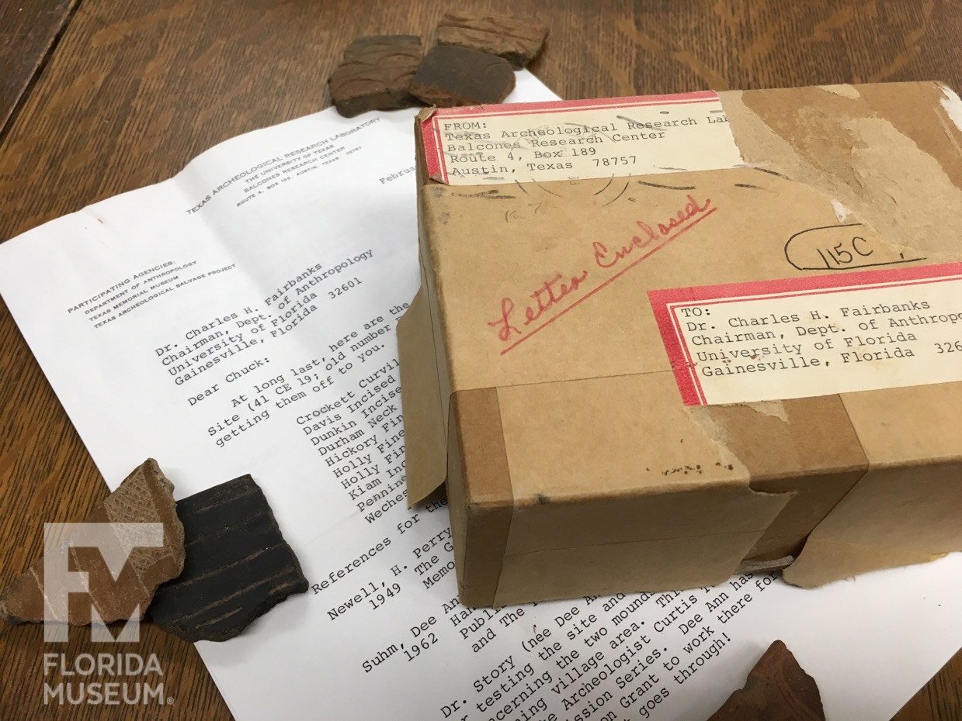

Figure 1. Box of Caddoan sherds that arrived to Dr. Charles Fairbanks at the University of Florida in 1966. Image courtesy Florida Museum of Natural History



Figure 2. A WPA-era archaeology lab. University of Tennessee Archaeology Laboratory circa 1934, analysis of site N-12 Norris Basin, Tennessee. Image courtesy McClung Museum of Natural History and Culture WPA/TVA Archive (fhm01876).

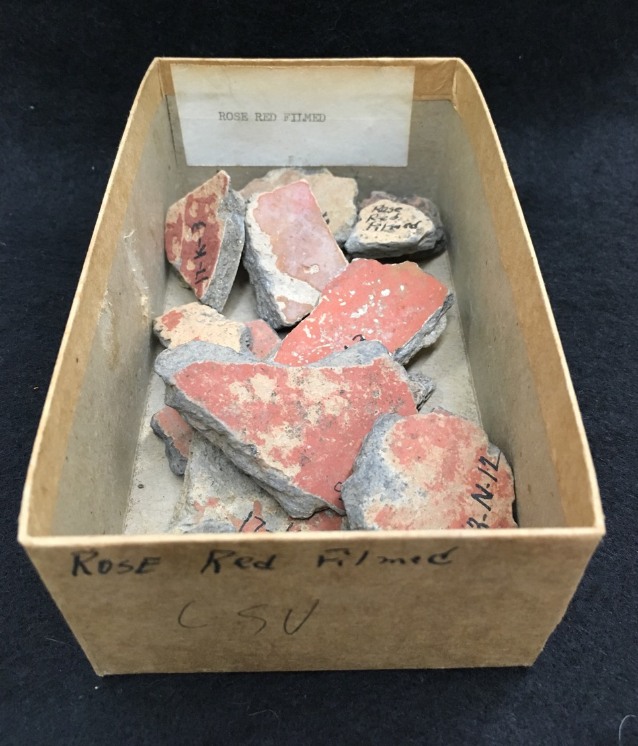

Figure 3. Sherds of Rose Red Filmed, aka Old Town Red. Image courtesy Florida Museum of Natural History.